This is the resource that I want to use as the starting guide for the background of working with python, the imports we will be using, and setting up the coding environment.

Right now our code base is built on 3 years of terrible coding practices and bad libraries. we would still use matlab, however, a large issue with running experiments on matlab has to do with the serial communication speed. for some reason, the serial communication becomes very slow between the arduino and matlab. on solution is to introduce another matlab toolbox which can be very expensive. to combat this, we are moving everything to python to add support for more general programming functionality not gate kept by paid toolboxes, while retaining easy development and increasing computational speeds.

python is a really great language for fast development and more higher level computational tasks, just like matlab. the reason we aren't moving to something super fast like C++ is because of how complicated C++ since its a lower level language.

to set up a coding environment:

install python ver 3.x: <https://www.python.org/downloads/>

be sure to add python to path when prompted

download vscode: <https://code.visualstudio.com/download>

install the python extension: <https://marketplace.visualstudio.com/items?itemName=ms-python.python>

Click to the right of the green arrows to configure the python interpreter



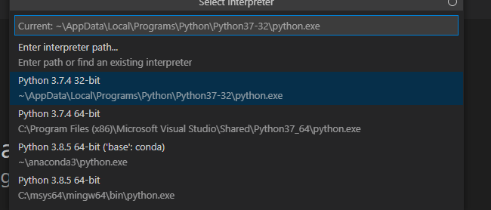

Yours should be python 3.9

open a new file and test out your that python is installed correctly

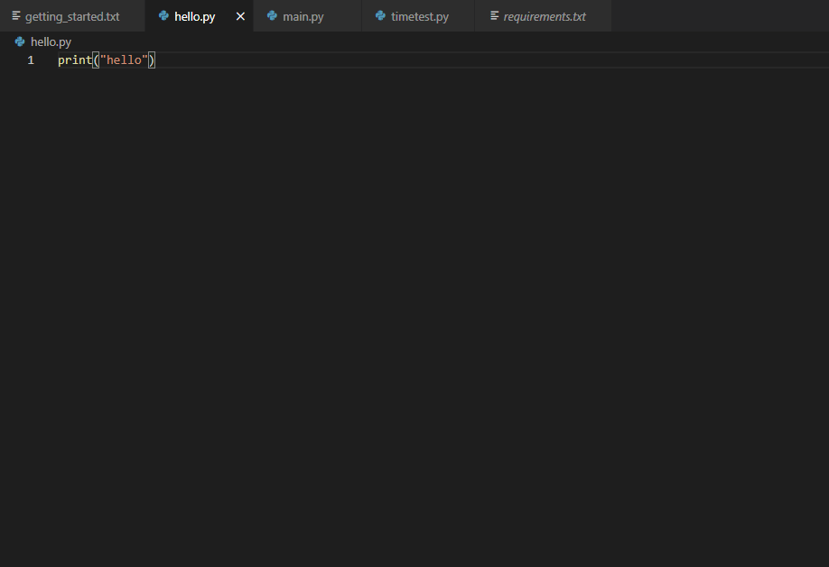

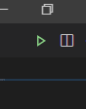

click the green run in the top right of the window

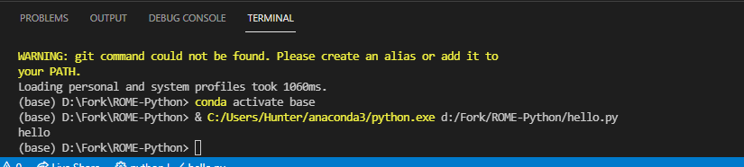

You should see the output in the console.